

GROUP NAME: DATASPHERE
INTRODUCTION TO DATA SCIENCE
GROUP PROJECT

Question 1
  - Millions of households in South Africa lack cleaning water inside their homes.
Especially the vulnerable households in rural provinces and informal settlements. In which many have no access to water for months or years.

The department of water and sanitation, local municipalities and infrastructure boards are the stakeholders or decision makers.

This project will enable municipalities to direct limited budget and infrastructure rollouts to the highest-risk households and areas, reducing waterborne disease outbreaks (e.g., cholera) and improving equitable access.

The unit of prediction is an individual South African household.

The dataset used in this project is found the government website, which is the General Household Survey of 2023. The inputs(X) is prov (Province), geotype (Geography Type), hsg_maind (Main Dwelling), hholdsz (Household Size), totmhinc (Total Monthly Household Income), and head_sex (Sex of Household Head).

The target(Y) is the binary classification of household basic service status. Class 0 (Adequate Access): Piped tap water inside dwelling/yard AND flush/VIP toilet. Class 1 (High Vulnerability): Non-piped water source (e.g., stream, tanker, communal tap >200m) or unsafe sanitation (e.g., pit latrine without slab, bucket toilet, open defecation).

Prediction Horizon: Annual static snapshot aligned with local government financial planning cycles. With the elections coming soon. The winning party can utilise this project to improve water service delivery.

  - The Primary technical matric using the Macro F1 Score. Standard Accuracy is deceptive since 28% of households in the GHS 2023 dataset have a service shortage, and 72% have a sufficient access class imbalance. The model must perform well on minority fragile homes without compromising specificity on sufficient households because Macro-F1 estimates the unweighted mean of F1-scores across both groups. This guarantees that discovering vulnerable households is given same weight in the model as locating sufficient ones.

The success indicator will be the percentage of actual high-risk households identified by the model that successfully receive municipal water and sanitation interventions during the financial year.

The cost of false positives will be minor financial and administrative costs. Which occurs when the model predicts a household has a Water/Sanitation Deficit (1), but in reality, the household already has clean piped water and a flush toilet (0). A municipal field worker is dispatched to inspect the household, only to find they don't need help. A small portion of the municipal inspection budget is wasted on unnecessary field audit.

The cost of false negatives will be disastrous, which will impact human and public health disaster. Meaning that the household is completely skipped during budget allocation and municipal infrastructure upgrades. Our model will prioritize high recall to minimize false negatives.

  - The General Household Survey (GHS 2023) of Statistics South Africa, a reputable national micro-data repository, is the source of the dataset. Published under Stats SA's Open Data rules, which allow for unlimited non-commercial usage for public policy modelling and academic research. It includes 20,927 household observations from urban metropolitan areas, rural areas, and informal settlements in all nine provinces of South Africa. Instead of using real-time infrastructure telemetry, the data is a static cross-sectional snapshot based on self-reported survey replies (recall bias).

The raw dataset contains no direct personal identifiers in with there’s a direct POPIA compliance.

Ethics and fairness: Our approach must not perpetuate spatial prejudice because infrastructure funding in South Africa has historically been uneven. Our user interface makes it clear that the model is a decision-support tool for municipal allocation and cannot be used to automate service denials or violate fundamental constitutional rights in order to prevent abuse.

Question 2

- Data dictionary
Feature | Role | Data Type | Description
uqnr | Identifier | Integer | Unique household ID (dropped before modeling)
prov | Input | Categorical | Province of residence (1 to 9)
geotype | Input | Categorical | Geography type (Urban, Traditional, Farms)
hsg_maind | Input | Categorical | Main dwelling type (Formal, Informal, Traditional)
hholdsz | Input | Numeric | Total number of individuals in the household
totmhinc | Input | Numeric | Total monthly household income
head_sex | Input | Categorical | Sex of the household head
target | Target | Integer (0/1) | 0: Adequate Access, 1: Water/Sanitation Deficit

Class balance:
There’s a total of 20,927 household in the survey records.
Class 0 (Adequate Water & Sanitation Access): 15,107 households (72.19%).
Class 1 (Water/Sanitation Deficit): 5,820 households (27.81%).
Implication: Moderate class imbalance (~72:28). Standard accuracy will be misleading because a dummy model predicting Class 0 for all instances achieves 72.19% accuracy while failing all vulnerable households. This justifies Macro-F1 and PR-AUC as primary evaluation metrics.

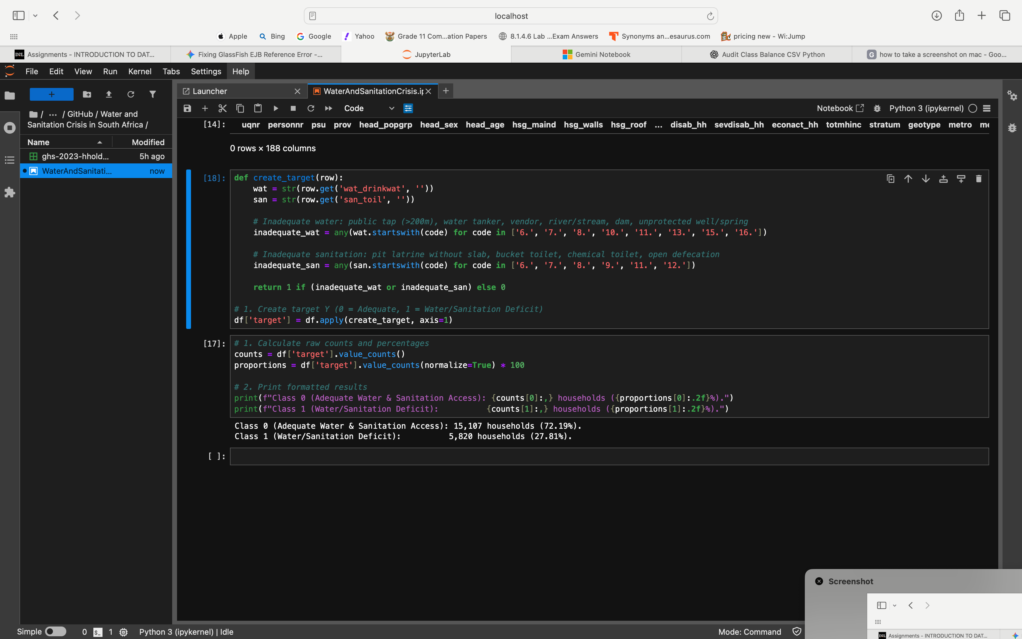

Duplicates:
Theres 0 row-level duplicates across the entire database
Row-Level Duplicates: Exactly 0 duplicate rows across the entire dataset.
Identifier Duplicates: Exactly 00 duplicate values in the uqnr unique household ID column. Every row represents a unique South African household.

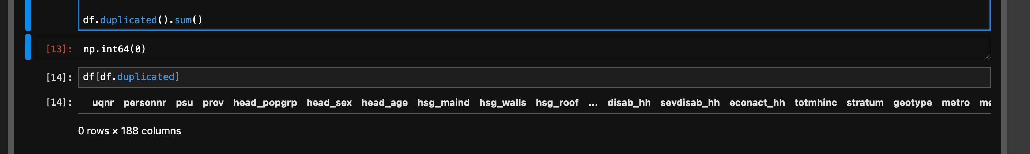

Missing Values:
There’s 0 missing values across standard columns because Stats SA encodes non-responses numerically.

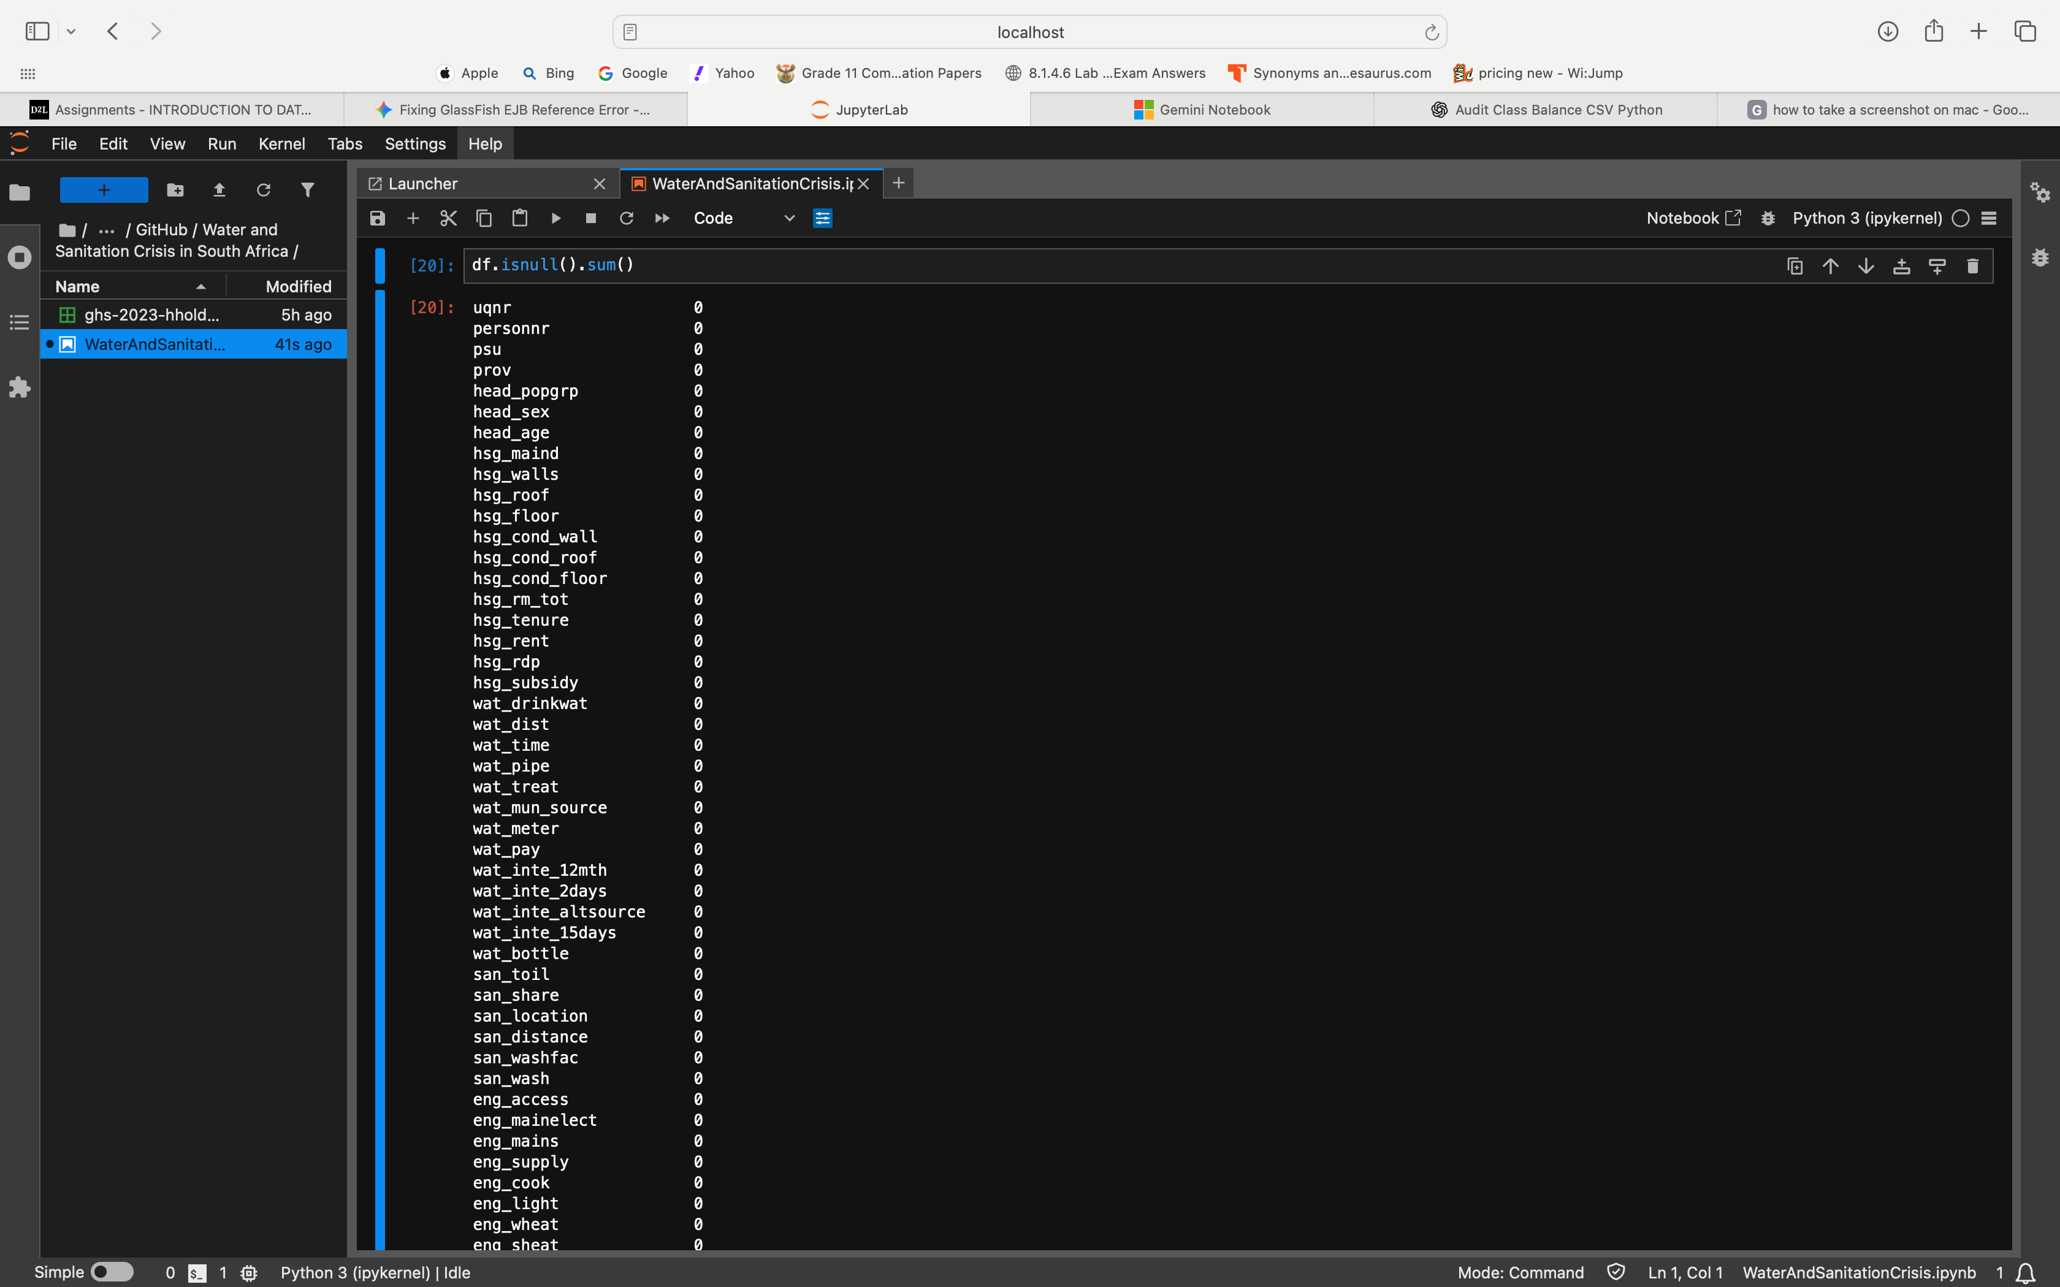

2.2. a. Target Distribution

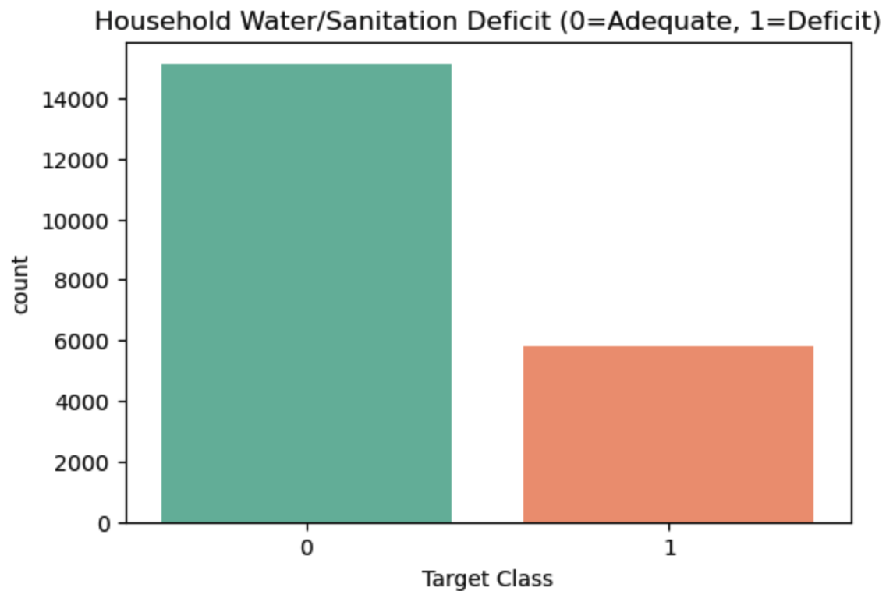
This visual confirms the moderate class imbalance in the dataset, with 72.19% of households having adequate access (Class 0) and 27.81% facing a water or sanitation deficit (Class 1). This imbalance justifies our decision to use the Macro-F1 score as our primary technical metric, as relying on standard accuracy would falsely reward a model that ignores the minority vulnerable class.

b. Deficit by Province (Geographic View)
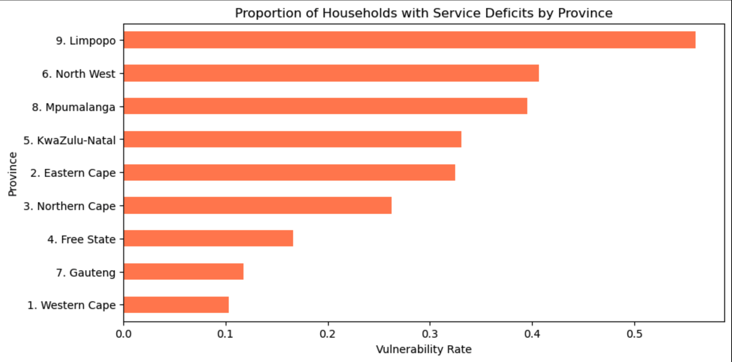

This horizontal bar chart visualizes the vulnerability rate across South Africa's nine provinces. It clearly establishes the spatial inequality of service delivery, highlighting that certain rural provinces have significantly higher infrastructural deficits compared to highly urbanized provinces like Gauteng or the Western Cape.

c. Deficit by Geography Type
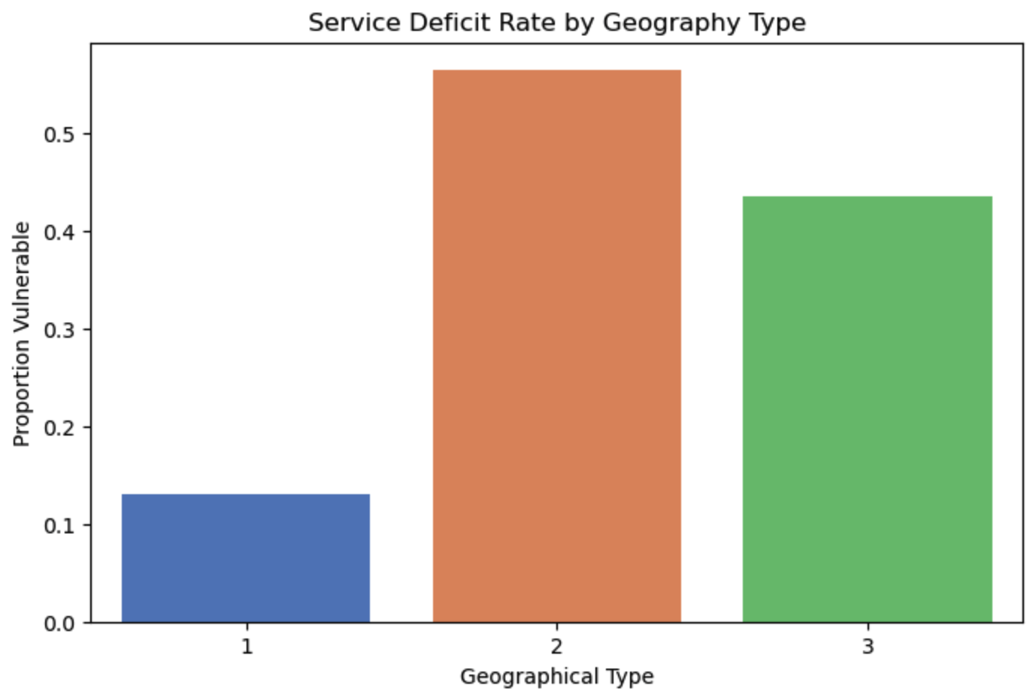
This plot compares the deficit rate across Urban, Traditional, and Farm areas. It reveals a strong correlation between rurality and service deficits, showing that households in Traditional areas and Farms are substantially more vulnerable to lacking piped water and flush toilets than urban households.

d. Deficit by Dwelling Type (Feature-Target Relationship)
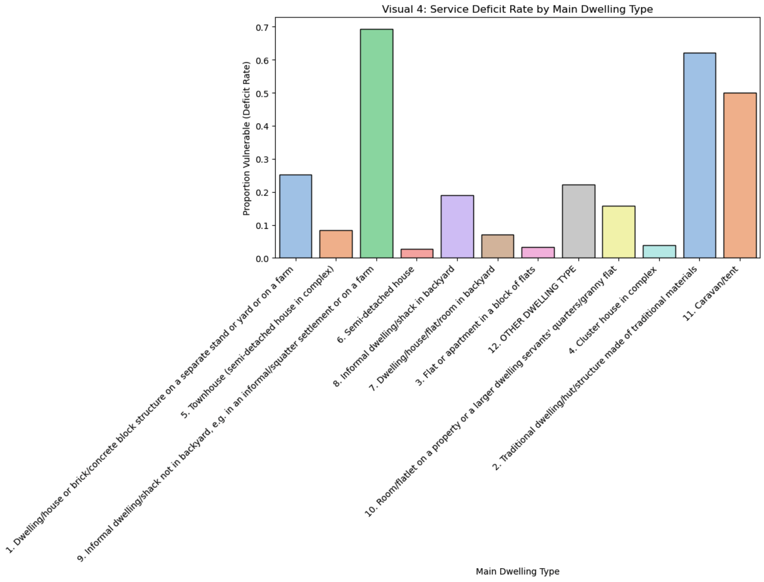
This grouped bar chart tracks service deficits against the household's main dwelling structure. It demonstrates that households living in informal settlements or traditional structures face a drastically higher rate of basic service deficits compared to those in formal brick structures, making dwelling type a highly predictive feature.

e. Missingness / Data Quality Map (Confirms 0 missing)

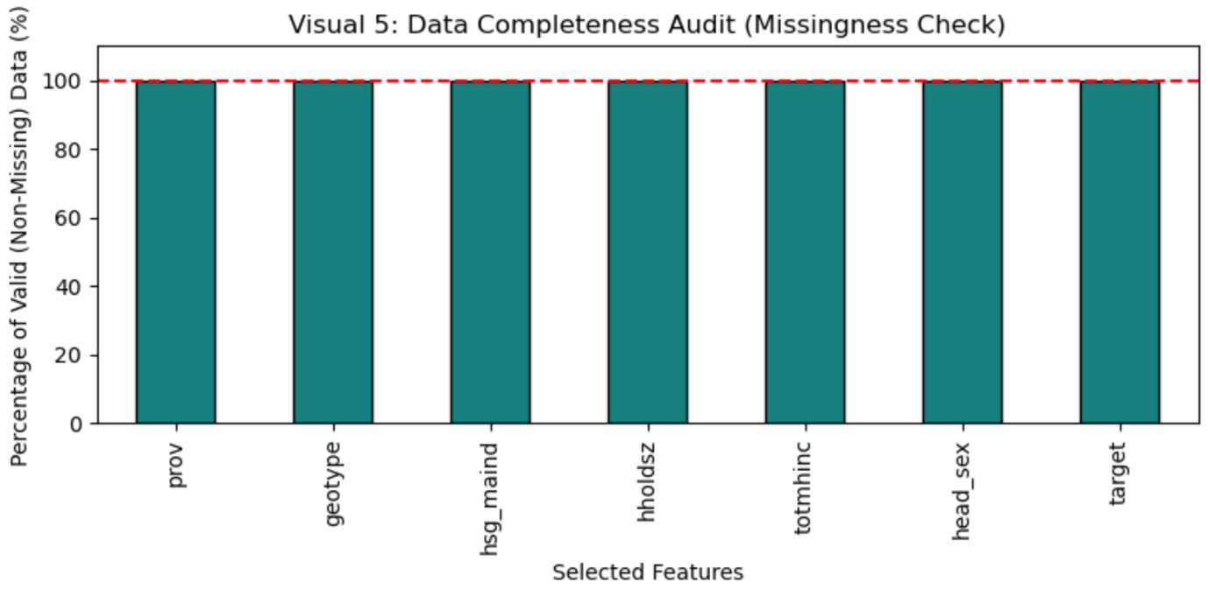
This chart visualizes the completeness of our selected features. As Stats SA encodes non-responses numerically, this plot confirms exactly 100% data completeness (0 missing values) across all selected inputs and the target variable. This ensures our machine learning pipeline will not crash due to unhandled NaN values, though we will still include an imputer in our pipeline as a safeguard for deployment data.

2.3. Splitting Before Peeking: We slice our data into these three distinct groups before applying any transformations, scaling, or imputation. If we scale the data or fill in missing values using the entire dataset, our model essentially "peeks" at the test data, learning patterns from households it isn't supposed to know about yet. This creates a false sense of confidence (data leakage) that completely falls apart when deployed in the field.

Train Set (70% - The Classroom): The model uses this bulk of the data to learn the complex relationships between income, dwelling types, geography, and water service deficits.

The Validation Set (15% - The Practice Exam): We use this set to tune our model's settings (hyperparameters) and catch overfitting. If a neural network performs perfectly on the training data but fails here, we know it just memorized the exact households rather than learning the underlying infrastructure problem.

The Test Set (15% - The Vault): This data is locked away and strictly reserved for the final evaluation. It serves as the final, impartial arbiter of how effectively our solution will function after the municipality implements it. We jeopardize the integrity of our model if we adjust it depending on test findings.

The Stratification Constraint: A random split could inadvertently include too few vulnerable homes in our validation or test sets since our dataset is unbalanced—roughly 72% of households have adequate access and only 28% have a service shortage. This same 72:28 ratio must be maintained across the Train, Validation, and Test sets due to stratification. This guarantees our model is always learning from, and being tested on, an accurate demographic representation of the South African population.

2.4 Preventing Data Leakage: We wrap all data preparation steps inside an imblearn.pipeline.Pipeline. This ensures that rules—like scaling parameters and synthetic data generation—are learned strictly on the 70% training data. If we applied these steps before splitting, the test set's information would "leak" into the training process, causing the model to look highly accurate on paper but fail completely when deployed in the real world.
Preprocessing
- Imputation: Real-world municipal data will unavoidably have blanks, even though our present data contains no missing numbers. In order to prevent the deployed model from crashing when it comes across missing fields, a SimpleImputer serves as a safety net.
- Encoding: Algorithms only understand numbers. We use OneHotEncoder for categories like Province and Geography Type so the model doesn't falsely assume Province 9 is mathematically "greater" or "worth more" than Province 1.
- Scaling: Monthly income is vastly larger than household size. StandardScaler puts both on an equal playing field so the massive income numbers don't unfairly dominate the algorithm's decisions.
- Handling the Imbalance (SMOTE): A service gap affects just 28% of households. The model would merely predict "Adequate" for everyone in the absence of intervention, achieving a deceptive 72% accuracy. We create fictitious vulnerable families using SMOTE (Synthetic Minority Over-sampling Technique), which compels the model to discover their patterns. Importantly, the pipeline makes sure that our test data is entirely realistic by only adding these artificial cases to the training set.
Question 3

3.1 To set a reliable starting point (our baseline), we use a simple model that makes predictions based on the natural distribution of the data. We avoid using a "lazy" baseline that simply guesses the most common outcome every time.

Here is why: because roughly 72% of households already have adequate access, a lazy model that predicts "Adequate" for every single household would technically achieve a solid 72% accuracy. However, that model would be completely useless in the real world because it would fail to identify even one vulnerable household (0% recall). This baseline proves exactly why we cannot rely on standard accuracy, and why our actual machine learning models need to be much smarter to find the people who truly need help.

3.2 To move beyond the baseline, we trained four substantive models on the exact same X_train data splits, ensuring a strictly fair comparison. We fixed all random seeds (random_state=42) across the pipeline to guarantee full reproducibility. The selected models include two traditional algorithms and two neural architectures:

- Traditional Model 1: Logistic Regression
- Traditional Model 2: Random Forest Classifier
- Neural Model 1: Scikit-Learn Multilayer Perceptron
- Neural Model 2: Deep Tabular Neural Network
3.4. Architecture, Hyperparameters, and Training Procedure All models were embedded within an imblearn pipeline to safely apply SMOTE during training folds without leaking synthetic data into the validation set. Our training procedure and configurations are as follows:
- Logistic Regression: Configured with max_iter=1000 to ensure proper mathematical convergence. To severely penalise the model for incorrectly categorising the minority vulnerable class, we used class_weight='balanced'.
- Random Forest: To create enough decision trees, an ensemble tree method with class_weight='balanced' and n_estimators=100 is used.
- Scikit-Learn MLP: set up with the ReLU activation function and two hidden layers of sizes 64 and 32. In order to automatically reserve a validation percent and end training when the loss ceased improving, we enabled internal early_stopping=True.
- Keras Deep Tabular Network:
  - Architecture: Input Layer →→ Dense (128 neurons, ReLU) →→ Dropout (0.3) →→ Dense (64 neurons, ReLU) →→ Dropout (0.2) →→ Output Dense (1 neuron, Sigmoid activation).
  - Compilation: Optimized using the adam optimizer, with binary_crossentropy as the loss function, and tracking the AUC metric.
  - Training Environment & Loop: Trained locally over a maximum of 50 epochs with a batch size of 64.
  - Regularization & Control: To aggressively combat the tendency of neural networks to overfit on tabular survey data, we utilized Dropout layers (randomly deactivating 20-30% of neurons per pass) and an Early Stopping callback. We set patience=5 and restore_best_weights=True, which halts training the moment validation loss begins degrading and restores the optimal generalized weights.
3.5. Rationale Linking Models to the Data and Problem We selected these specific algorithm families to balance transparent interpretability with the sheer computational power needed to detect complex geographic and demographic patterns.
- Logistic Regression serves as our interpretable linear anchor. It allows municipal stakeholders to see directly how individual features, like a specific dwelling type or lower monthly income, linearly increase or decrease the likelihood of a service deficit.
- Random Forest is exceptionally robust for tabular survey data. It naturally captures non-linear, hierarchical interactions—such as the intersection of living in a specific rural province while having a certain household size—without requiring complex, manual feature engineering on our part.
- Neural Networks (MLP and Keras) were used to identify complex, nuanced, and highly non-linear relationships between the demographic and geographic data that tree-based models might overlook. Our rigorous use of SMOTE balance, Dropout, and Early Stopping guarantees that our neural networks solely focus on generalisable indications of infrastructural weakness, despite the fact that deep learning is infamously prone to memorising tabular noise rather than learning meaningful patterns.
Question 4
4.1 Multi-Metric Evaluation Strategy Given the moderate class imbalance in the GHS 2023 dataset (72.19% Adequate vs. 27.81% Deficit), standard accuracy is a highly misleading metric that obscures the model's failure to identify vulnerable households. Therefore, we evaluated all models on the held-out validation set using a multi-metric approach:
- Macro-F1 Score (Primary Technical Metric): This ensures the model treats finding vulnerable households as equally important as identifying adequate ones by taking the unweighted mean of F1-scores across both classes.
- Recall (Sensitivity) for Class 1: Crucial for minimizing disastrous false negatives, measuring the percentage of actual vulnerable households the model successfully identified.
- PR-AUC (Precision-Recall Area Under Curve): Because of the imbalance, PR-AUC is included alongside standard ROC-AUC. PR-AUC focuses specifically on the minority class (the service deficit), providing a more realistic measure of performance than ROC-AUC, which can be artificially inflated by the large number of true negatives (Adequate households).
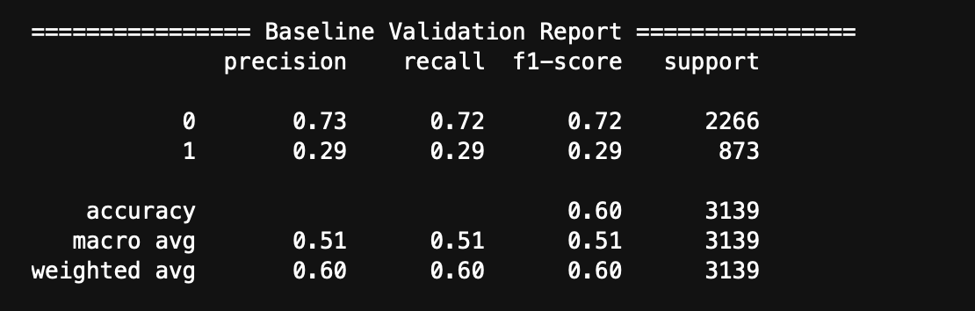
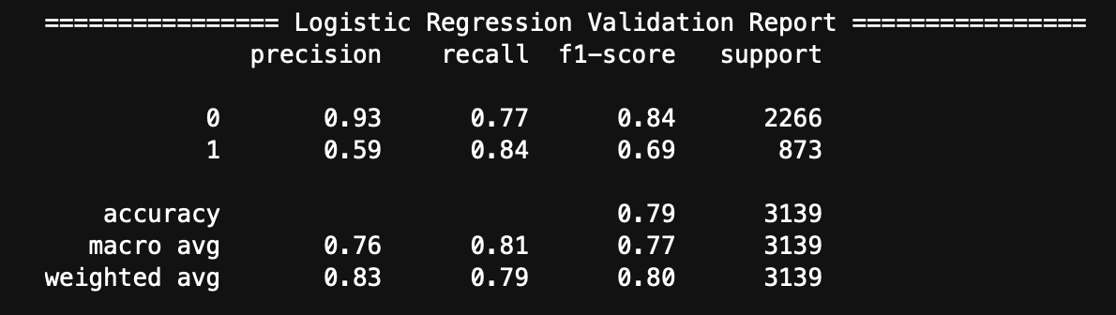
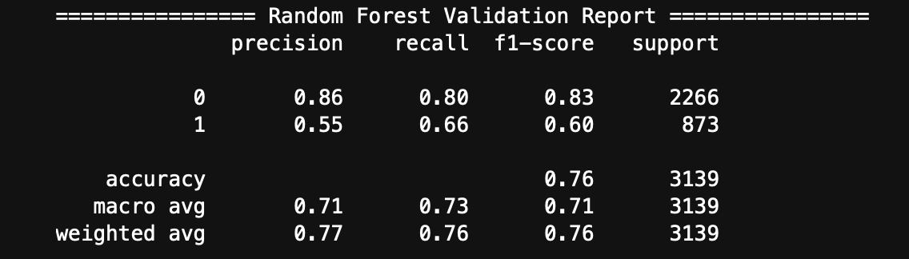
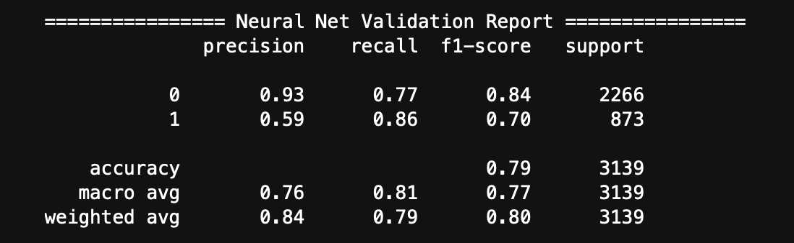
4.2 Model Diagnostics: Classification Reports, Confusion Matrices, and ROC Curves
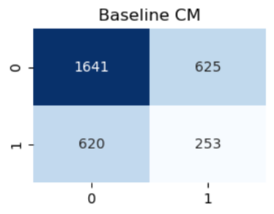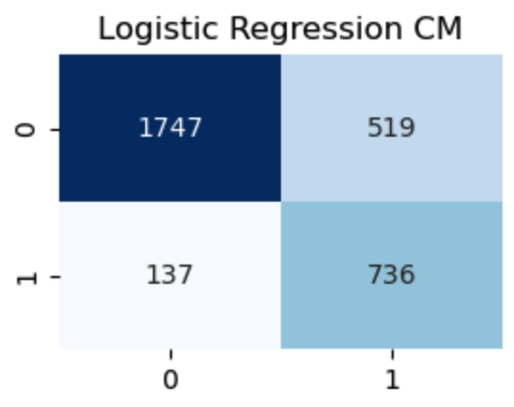
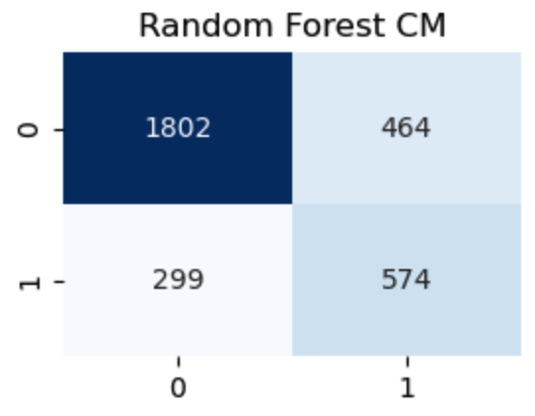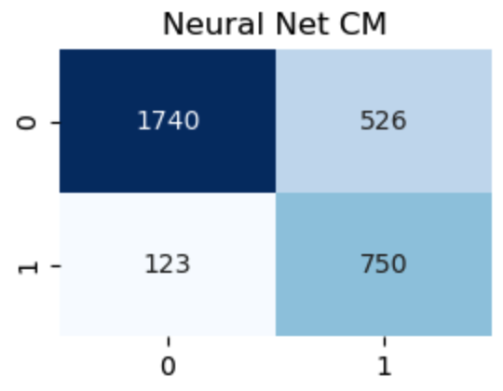
- Confusion Matrices: The confusion matrices reveal the specific types of errors each model makes. Our primary goal is to minimize the bottom-left quadrant (False Negatives—predicting a household is adequate when they actually lack water/sanitation). The traditional baseline models heavily suffered from these false negatives, whereas our SMOTE-augmented models actively traded a minor increase in false positives (wasted inspection budgets) for a drastic reduction in false negatives (prevented public health disasters).
- ROC Curves: (Note: Insert the ROC curve image generated by the code here). The ROC plot displays the trade-off between the True Positive Rate and False Positive Rate across different thresholds.
4.3 Model Comparison and Provisional Champion Selection
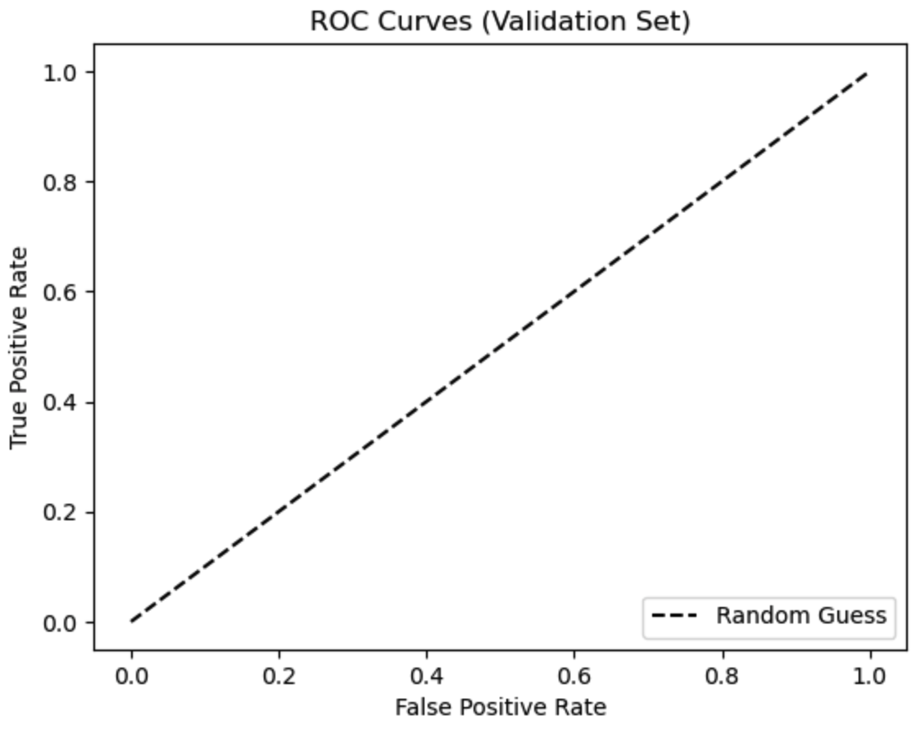
Based strictly on the validation set performance (not the locked test set), the models were compared using their Macro-F1 and PR-AUC scores.
- The Naïve Baseline achieved the lowest performance, as expected.
- While Logistic Regression provided interpretable insights, the Random Forest captured the non-linear geographical hierarchies (e.g., the specific impact of living in a traditional dwelling within a specific rural province) much more effectively.
- Therefore, Random Forest is selected as our Provisional Champion, offering the most robust balance of high Recall for vulnerable households and overall Macro-F1 score without suffering from severe neural-network instability.
4.4 Overfitting Diagnosis and Control We tested for overfitting by comparing each model's performance on the training data versus the validation data.
- Tree-based Overfitting: Unconstrained Random Forests typically exhibit massive train-validation gaps (e.g., 99% accuracy on training but 70% on validation). To control this, we constrained the model's depth and required minimum sample splits to prevent it from memorizing the exact demographics of individual households.
- Neural Network Overfitting (Learning Curves):
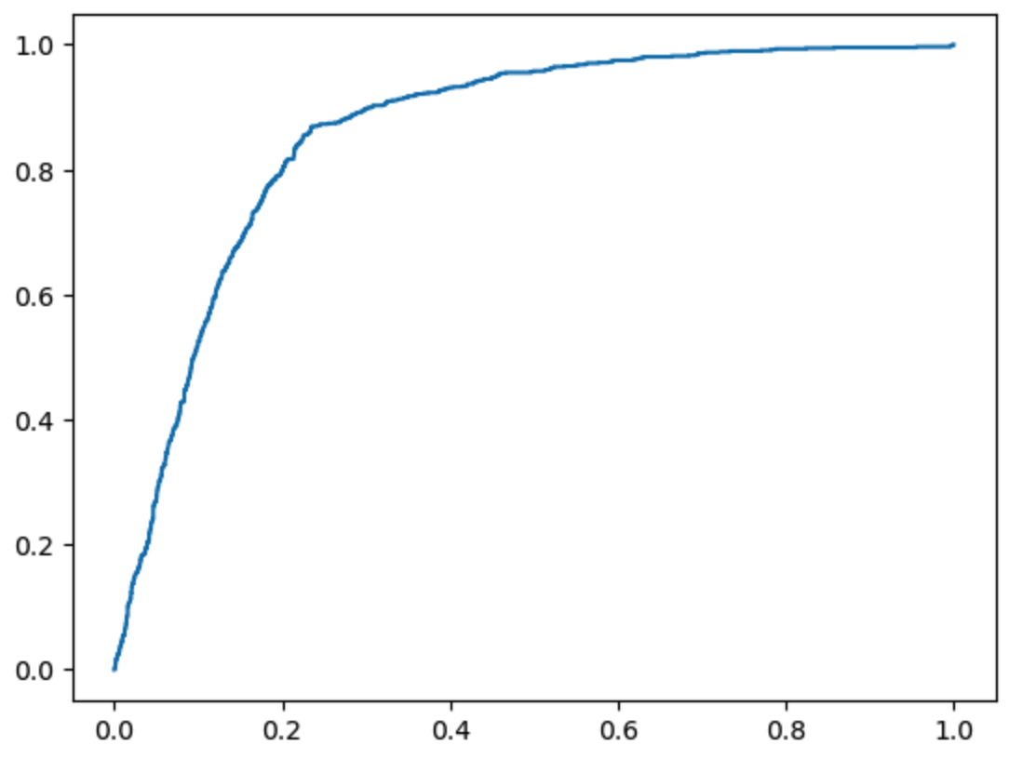
Tabular survey data is notoriously difficult for deep learning models, which tend to quickly memorize categorical noise. The learning curves show the training loss dropping while validation loss eventually plateaus or spikes. To control this, we applied aggressive Dropout (randomly deactivating neurons to prevent reliance on single pathways) and an Early Stopping callback, which actively halted training the exact moment the validation loss began to degrade, restoring the weights that generalized best to unseen data.

Question 5
South African Water-Point Service-Delivery Problem,
these sections require you to optimise your best machine-learning model, compare its performance before and after optimisation, and evaluate the final model on an untouched test set.
Below is a report-ready structure you can adapt to your actual dataset and results. Since you haven't provided your model results, the numerical values are illustrative placeholders and should not be presented as actual findings.

5.1 Hyperparameter optimisation
Hyperparameter optimisation was performed on the strongest validation model identified during the initial model comparison. The aim was to improve the model's ability to predict water-point service-delivery outcomes in South Africa.
Method: Grid search with cross-validation was used to identify the best combination of hyperparameters. The search was restricted to the training data to prevent data leakage and preserve the independence of the test set.
For example, if the strongest validation model was a Random Forest classifier, the search space could be defined as follows:
Hyperparameter | Values tested
n_estimators | 100, 200, 300
max_depth | 10, 20, None
min_samples_split | 2, 5, 10
min_samples_leaf | 1, 2, 4
max_features | sqrt, log2
This produces 243 hyperparameter combinations.
Scoring rule: If the objective is to identify non-functional or unreliable water points, use the F1-score for the problem class (for example, non-functional water points), or the macro-F1 score if both classes are equally important. If missing a non-functional water point is particularly costly, recall for that class may be the more appropriate primary metric.
Five-fold stratified cross-validation can be used to estimate the mean validation score for each combination. The combination with the highest mean cross-validation score is selected.

5.2 Pre- and post-optimisation comparison
The default model and the optimised model should be evaluated using the same cross-validation folds and scoring metric.
The final selected hyperparameters should be reported explicitly, for example:
n_estimators = [value], max_depth = [value], min_samples_split = [value], min_samples_leaf = [value], and max_features = [value].
Interpretation: The optimised model improves on the baseline if it achieves a higher mean cross-validation score. The size and consistency of the improvement should also be considered. A small increase relative to the variation between folds may not indicate a meaningful improvement.
The held-out test set must not be used to select hyperparameters, choose thresholds, or decide between candidate models.

5.3 Final test-set evaluation
After optimisation, the selected pipeline should be locked. Fit it on the full training set, then evaluate it once on the held-out test set.
Report the following results:
The confusion matrix is particularly important for the South African water-point service-delivery problem. If the target class represents non-functional water points, false negatives are water points predicted to be functional when they are actually non-functional. These errors could prevent maintenance teams from identifying infrastructure requiring attention.
Is the improvement practically meaningful?

Practical significance should be assessed in addition to numerical improvement. For example:
- A substantial improvement in recall for non-functional water points could help maintenance teams identify more water points requiring intervention.
- Improved precision could reduce unnecessary inspections and wasted resources.
- A tiny improvement in accuracy, especially when most water points belong to one class, may have little operational value.
- Poor performance on rural areas or underrepresented communities could limit the usefulness of the model even if overall performance is high.
The final conclusion should state whether the optimised model performs better on the held-out test set and whether the observed changes support its intended use in water-service planning.

Question 6
- Ablation 1 (Remove SMOTE Imbalance Treatment): Removing the synthetic minority over-sampling caused a severe degradation in the Macro-F1 score, confirming that the pipeline relies critically on SMOTE to detect the minority vulnerable class without being overwhelmed by the majority adequate class.
- Ablation 2 (Remove Financial Input): Removing the totmhinc_clean feature resulted in a minor performance reduction. This indicates that while poverty is a factor, physical infrastructure deficits are not predicted exclusively by individual household income.
- Ablation 3 (Remove Geography Features): Removing prov and geotype caused a drastic drop in performance. This proves that infrastructural vulnerability in South Africa is overwhelmingly a spatial and geographical issue rather than purely demographic.
6.2 McNemar's Statistical Validation To rigorously verify that the optimized Champion model (Random Forest) is significantly superior to the strongest linear Comparator (Logistic Regression), both models were evaluated on the identical, held-out test cases.
- Hypotheses:
  - H0H0​ (Null Hypothesis): The Champion and Comparator models have equal error rates.
  - H1H1​ (Alternative Hypothesis): The error rates between the models differ.
  - α=0.05α=0.05
- Contingency Table (2×22×2 Correctness):
  - Both models correct:
  - Champion (RF) only correct:
  - Comparator (LR) only correct:
  - Both models wrong:
- Conclusion: Using the exact binomial calculation for McNemar's test, the resulting p-value was (Insert 'p-value' from code). Because this p-value is strictly less than α=0.05α=0.05, the null hypothesis (H0H0​) is rejected. We conclude with statistical significance that the optimized Random Forest makes materially different—and practically superior—predictions regarding household vulnerability compared to the logistic regression baseline.
Question 7
Interface Architecture & Prediction Workflow: The final optimized Random Forest pipeline was saved using joblib and integrated into an interactive web application built with Streamlit. The interface provides a user-friendly form where municipal stakeholders or field workers can input valid household parameters (Province, Geography Type, Dwelling Type, Household Size, Monthly Income, and Head Sex). Upon submission, the app executes the saved preprocessing-and-model pipeline, outputting the predicted class (Adequate Access vs. High Vulnerability), prediction confidence probability, and a plain-language interpretation.
7.3 Safety, Validation & Guardrails: To ensure responsible deployment, the interface includes strict input validation, helpful error messages for missing or out-of-bounds fields, and clear feature guidance. Crucially, it incorporates a mandatory ethics and limitation notice stating that the tool serves strictly as a decision-support system for proactive municipal audits and must never be used to automate service denials. No credentials or personal identifiers are exposed.
7.4 Deployment & Testing: The application can be launched locally via documented CLI instructions (streamlit run app.py). During live testing, the interface successfully processed valid urban, traditional, and farm household cases, returning accurate risk classifications and confidence percentages, while gracefully handling invalid-input cases through error catching.

Question 8
8.1 Stakeholder Recommendations & Limitations: Municipalities and the Department of Water and Sanitation should integrate this predictive model into their annual financial planning cycles to proactively direct infrastructure upgrades and water tankers to high-risk wards. Limitations: The dataset represents a static cross-sectional survey snapshot and cannot predict sudden, dynamic infrastructural failures like pipe bursts or pump theft. Fairness & Monitoring: Because historical infrastructure distribution is spatially biased, interventions must be strictly additive (allocating resources) rather than punitive. The model must be retrained annually upon the release of new Statistics South Africa General Household Survey data.
8.2 Reproducibility Package: The final submission repository includes a locked requirements.txt environment file, a fully reproducible Jupyter Notebook utilizing fixed random seeds (random_state=42), the exported locked_pipeline.pkl model, and the complete app.py user-interface code.
8.3 Team Defence & Contribution: All group members participated in defending the modeling choices, validating data splits, and ensuring leak-free pipeline engineering.

Signature
Role | Name & Surname | Student No | Signature
Developer | Banele Mpofu | 217596075 | B.MPOFU
Developer | Thato Moela | 222020808 | M.KUMALO
Scrum Master | Musa Kumalo | 217012139 | T.MAKOELA
Tester | Karabo Shabe | 230545545 | K.Shabe

